Ridgefield “Visit Us” Webpage

**Check in 10/26/2022:**

* How much in a photo is too much?
  + Take multiple photos to determine which is too much.
    - Less walking and driving
* Short photo description examples:
  + Maybe the Access Trails website as a template?
    - <https://www.accesstrails.org/overview/tualatin-river-wildlife-refuge/index.html>
    - <https://www.accesstrails.org/overview/steigerwald/index.html>
    - 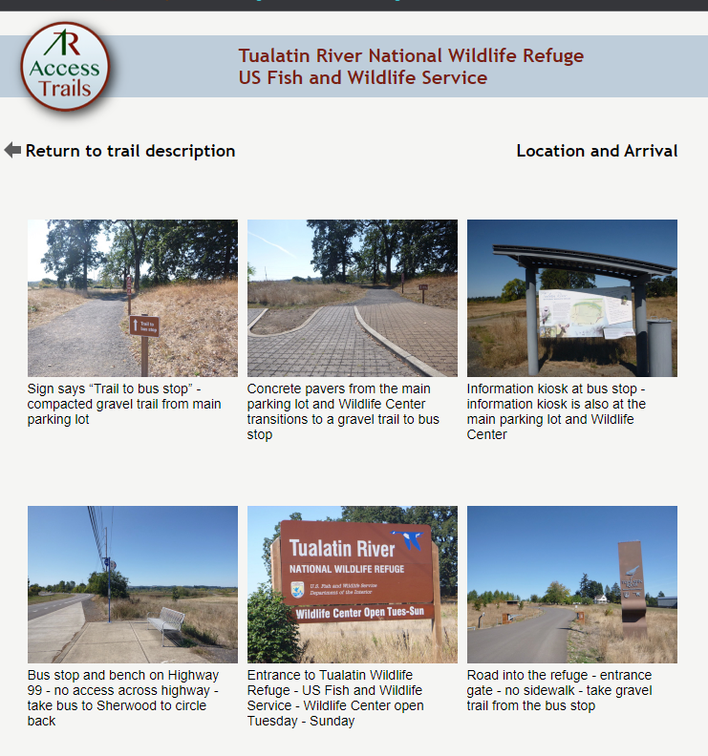

**Carty Entrance: (Meta data/description will be implemented once pictures have been finalized)**

* Gate Entrance:
  + 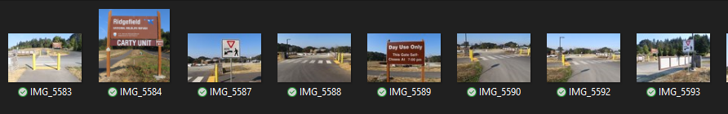
  + 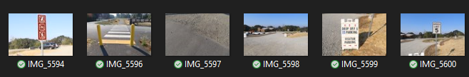
* Upper Parking:
  + 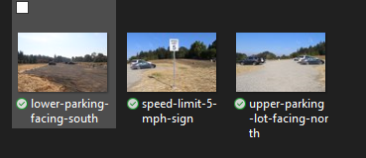
* Upper Parking Pathway:
  + 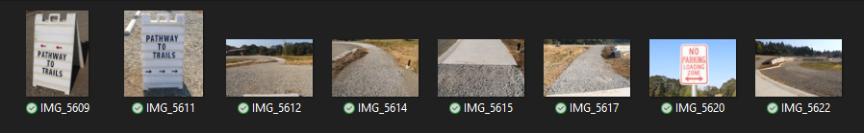
* Lower Parking:
  + 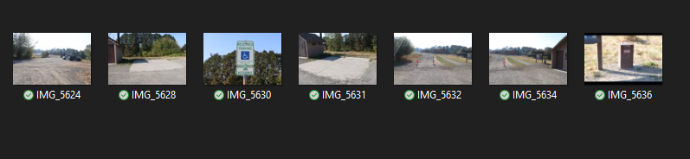
* Exterior New Building:
  + 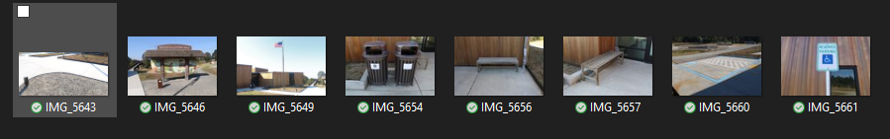
* Interior New Building:
  + 